Finding the Essential Skills related to your occupation (Job Profiles)
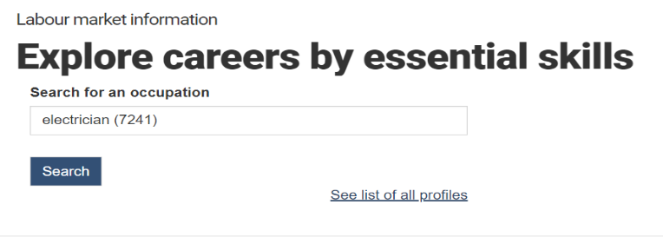
Please research the essential skills profile for your chosen occupation by visiting the following website: https://www.jobbank.gc.ca/essentialskills

Once there type in the name of your occupation and select the correct NOC code (there may be several attached to the general occupation name)

then select the Search button
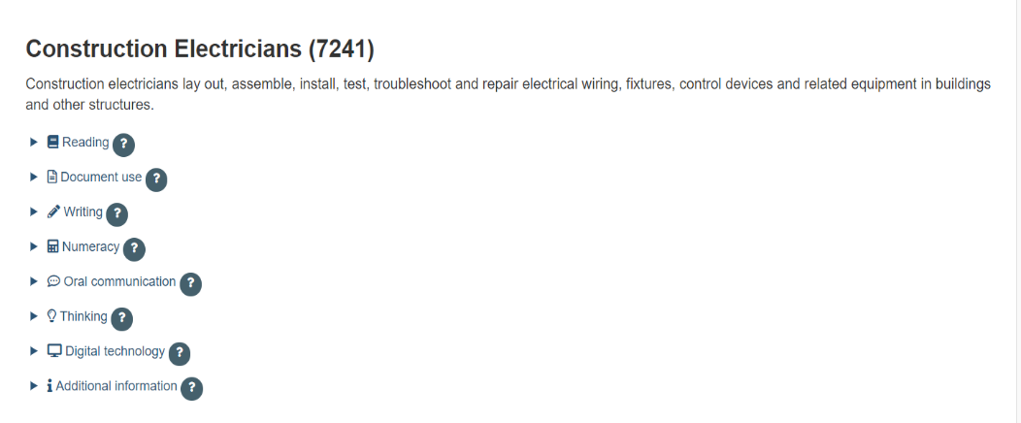
Scroll down the page until you find the blue linked Essential skill labels. The example to the right is for electricians.

You can select the skill and it will show examples of the types of activities related to the skill that you will need to be able to do in the occupation.

Essential skill descriptions
The profiles are organized by essential skill. Each essential skill section contains the following key elements:
- Example tasks: a list of essential skills-related tasks. This list describes the different types of tasks workers may be expected to do for each essential skill in an occupation.
- Complexity ratings: the number found in brackets beside each example task. These estimated numbers range from Level 1 (basic) to Level 5 (advanced), depending on how difficult the task is. The complexity levels may vary based on the requirements of the workplace.
- Essential skill function overviews: describe the purpose and/or use of each essential skill (except for Thinking). This section, usually presented in a table format, is omitted from short versions of the profiles.
- Impact of digital technology - New - updated profiles include new information on the effect digital technology has on the essential skills-related tasks required in an occupation.
  - In long versions of the updated profiles, this information is found after the list of example tasks for each essential skill (see outline in Appendix A).
  - In short versions of the updated profiles, this information is summarized at the end of the profile in an "Impact of Digital Technology" summary (see outline in Appendix A).

More Essential Skills Resources:
https://www.canada.ca/en/employment-social-development/programs/essential-skills/profiles.html
https://www.canada.ca/en/employment-social-development/programs/essential-skills/profiles/guide.html
Self Assessment tools: https://www.canada.ca/en/employment-social-development/programs/essential-skills/tools.html

Labour Market Information Resources:
Canada LMI: LMI Explore | Home (clmi-explore-icmt.ca)
Explore careers: https://www.jobbank.gc.ca/content_pieces-eng.do?cid=5223
(by occupation, wages & outlook, education program, skills&knowledge)

Completing the Essential Skills Tracking Sheets
Read the profiles and select a few to copy and paste into the template from the Weebly (see example below).
In conference with your Co-Op supervisor you can select a few to craft a SMART goal to work on while at work.
Note that you can copy and paste directly from the profiles, but you can also edit them once they have been pasted into the sheet. The editing should be completed after you have met with your supervisors.

If you wish, you can copy a number of skill profiles onto a series of sheets but please do not select any more than 3 to work on at a time – and you should plan to spend at least a few weeks on each.

Please note: Some of the skills you will not be able to do or work on, but you may be able to observe so you can become familiar with what is involved in the skill (like programming a PLC).

Essential Skills Tracking Sheets (Example)

Skill | Reading | Document Use | Numeracy | Writing | Oral communication | Working with others | Thinking | Computer use | Continuous Learning | Improvement Notes
Definition | Understanding materials written in sentences or paragraph (e.g. letters, manuals). | Finding, understanding or entering information (e.g. text, symbols, numbers) in various types of documents, such as tables or forms. | Using numbers and thinking in quantitative terms to complete tasks. | Communicating by arranging words, numbers and symbols on paper or a computer screen. | Using speech to exchange thoughts and information. | Interacting with others to complete tasks. | Finding and evaluating information to make rational decisions or to organize work. | Using computers and other forms of technology. | Participating in an ongoing process of improving skills and knowledge. | In your SMART Goal Sheet: Using SMART language explain how you are identifying goals and making progress with the skill (ensure dates for beginning, and progress notes)
Description from Profiles  (If required Modify this goal with your supervisor and write below) | Read a variety of instructions and procedures, e.g. read step-by-step instructions for the installation of light fixtures and electric heaters. (2) |  | Calculate electrical requirements, e.g. calculate current flows, resistances and voltages to select transformers and troubleshoot their faults. (2) |  |  |  | Decide order of tasks and their priorities, e.g. decide which electrical installations to complete first. (1) |  | (Digital Technology)  Use hand-held electronic devices like oscilloscopes and multimeters to locate operational data, such as electrical readings. (1) | Write 1 SMART goal per skill and have a supervisor monitor your progress. (Use the SMART goal sheets and just record monitoring notes here).
What is your current goal
(Date)
Essential Skills Tracking Sheets

Skill | Reading | Document Use | Numeracy | Writing | Oral communication | Working with others | Thinking | Computer use | Continuous Learning | Improvement Notes
Definition | Understanding materials written in sentences or paragraph (e.g. letters, manuals). | Finding, understanding or entering information (e.g. text, symbols, numbers) in various types of documents, such as tables or forms. | Using numbers and thinking in quantitative terms to complete tasks. | Communicating by arranging words, numbers and symbols on paper or a computer screen. | Using speech to exchange thoughts and information. | Interacting with others to complete tasks. | Finding and evaluating information to make rational decisions or to organize work. | Using computers and other forms of technology. | Participating in an ongoing process of improving skills and knowledge. | In your SMART Goal Sheet: Using SMART language explain how you are identifying goals and making progress with the skill (ensure dates for beginning, and progress notes)
Description from Profiles

(If required Modify this goal with your supervisor and write below)
What is your current goal
(Date)

What is your current goal
(Date)

